**Friends of Mossvale Park**

**ELECTION OF OFFICE BEARERS**

NOMINATION FORM

I, the undersigned, being a Member of the **Friends of Mossvale Park** hereby nominate for appointment for the position of (*President, Vice President, Treasurer, Secretary, Working Bee coordinator*) (**please circle respective position**)

**Name of NOMINEE:**

Mr/Mrs/Miss/Ms: ­­­­______________________________________________________­­­­­­­­_________

Phone: ____________________ E-mail:_________________________________________

**Name of NOMINATOR:** ________________________________________________________

Signature of Nominator: _________________________________________________________

Date:_________________________

**Name of SECONDER:** _________________________________________________________

Signature of Seconder: _________________________________________________________

Date:_________________________

**DECLARATION OF NOMINEE:**

I, _____________________________________________ being a member of the **Friends of Mossvale Park** agree to stand for election as a member of the Committee of Management for the position of (*President, Treasurer, Secretary, Working Bee coordinator*) (please circle respective position)

Signature of Nominee: _________________________________________________________

Date:__________________________

**PLEASE NOTE: ANY NOMINATION WILL BE INVALID IF ALL PERSONS NAMED HERE ARE NOT CURRENT MEMBERS OF THE FRIENDS OF MOSSVALE PARK.**

**Nominations will be accepted up to and during the meeting held at 1.00pm 11/7/2024 and from the floor of the meeting.**

**Email, Mail Nominations to:** The Secretary Jill Vella

Email: vella@dcsi.net.au

Postal address: 70 Caithness Road, Koonwarra 3954

**NOTICE OF THE 2025 ANNUAL GENERAL MEETING**

**Friends of Mossvale Park**

**Annual General Meeting to be held on Thursday 10th July at Leongatha**

Agenda:

1. Welcome, proxies and apologies
2. Annual reports – Executive report and Treasurer’s reports and financial statements
3. Election of Office bearers, President, Vice President, Treasurer, Secretary, Working Bee coordinator
4. Motions on notice.

* Motion of Banking -

“The Friends of Mossvale Park will continue to hold an account with the Bendigo Bank in Mirboo North. It will have three registered signatories, President, Treasurer, Secretary, with two of the three registered signatories required to sign for any transaction.”

* Setting of fees for next financial period.
* Ratifying membership of new applicants for membership
* Insurance

1. Any other business

Meeting close

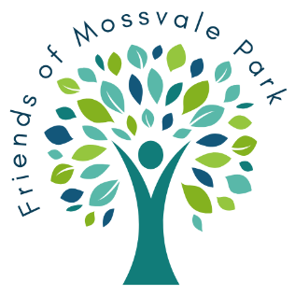

**APPOINTMENT OF PROXY**

**Friends of Mossvale Park**

I………………………………………………………..……of………………………………………………………………….

……………………………………………………………………………………………………………………………………...

being an eligible voting Member of the Friends of Mossvale Park, hereby

appoint……………………………………………………..…of……………………………………………………………….

………………………………………………………………………………………………………………………………….....

or failing him/her the Secretary for the time being of the Meeting as my proxy to attend and vote on my behalf at the Annual General Meeting of the group to be held on the 10th day of July 2025 and at any adjournment thereof.

My proxy is authorized to vote on my behalf.

Signed this………………….….day of…………………………………………2025

………………………………………………………

(Signature)