Mossvale Park Friends Group Meeting Minutes
Held Thursday February 5th 2026, at 11.00am in the Park.
Acknowledgement of Country –
'Our meeting is being held on the lands of the Gunaikurnai people and I wish to acknowledge them as Traditional Owners. I would also like to pay my respects to their Elders, past and present, and Aboriginal Elders of other communities who may be here today.’
Welcome President Jeremy Curtis opened the meeting at 11.13am
Attendees Jeremy Curtis, Coral Hughes, Suzanne Wightman, Jean Carnell, Les Hutchinson, Wayne McKay, Steve Lovie, Jeremy Tuxen, Robert Stephens, Jill Vella
Apologies Steve Missen
Minutes of Previous Meeting October 2nd 2025 https://www.mossvalepark.com/site_files/5304/upload_files/MossvaleParkFriendsGroupMeetingminutesOctober2nd2025.pdf?dl=1
These minutes are to be amended to reflect that Dick Lester’s resignation was tabled, not read.

Business Arising from previous minutes. Dogwoods have been moved.

Correspondence.
SGLN Tarwin River symposium 8 Nov. Jill and Robert attended.
Australian Charities and Not-for-profits Commission re annual information statement.
AGM of the RHSV
November working bee
Danny O’Brian re Landcare grant
SGLN Fund donation of $599.73
ACNC advice of annual information statement received.
SGSC grant payment form received.
SGSC grant successful and invitation to Jeremy and Jill to presentation ceremony.
John Patrick re letter of acceptance of quote
Google using words I do not understand about our account. Its all good though.

Reports -
Treasurers report Coral reported the balance in the bank was $3549.72
Jill noted she had purchased the laser engraver and tree labels and would submit the receipts for reimbursement.

Working Bees The team did some weeding, moved the dogwoods and watered them in. There were no reports from previous months. Jeremy T will contact Dick to get the working bee kit from him with the risk assessments and snake bite kit.

Tree Reports
The wattle tree at the end of Goulds glade has been cut up. There are some dead and dying trees that need work including the acer negundo, the new giant sequoia and the Claret ash in Gould’s glade. The magnolia planted in the drain spoil looks ill and may need to be relocated.
A new oak in a similar position to the old oak that was replaced by the dead giant sequoia will be planted to commemorate Dicks contribution to the park.

Steve Missen report Steve was just back from leave, so had nothing much to report, which was by telephone.
VLG grant
The laser engraver and tags have been purchased and will possibly be set up in the back of the Rotary shop for easy access to all volunteers. A test tag and some format options will be presented at the next meeting. Also a list of the species to be identified.
The sign will once again be forwarded to the friends for comment. Also to Steve Missen to seek formal council approval. Once we have agreed on the format, the next two signs will be designed.
Master Plan grant.
Jill and Jeremy attended the presentation ceremony that was held on the 4th of Feb (last night)
Belinda Brennan our community consultation facilitator has began preparing the survey questions. There will be a steering committee meeting on Feb 26th @ the WGWMA offices to discuss how we action our grant deliverables. The meeting discussed canvassing our survey at
- Mossvale music
- Mirboo North market
- Leongatha Market
- Leongatha Horticultural society
- Via Facebook and our website
A copy of the survey will be emailed to all the friends via email for input prior to the 26th Feb meeting.
A copy of all the grant docs will sent around for info and feedback.
Mapping/Web/Sign Report
The website had most engagement over the holidays during this reporting period. The data has been filtered to remove the high number of hits from china and the USA which are no doubt potentially nefereous.
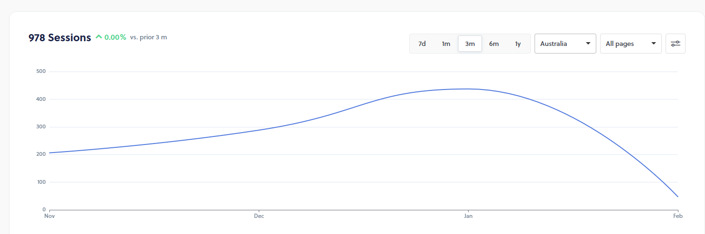
The new map for the Moss and Gould history trail is complete with the trail booklet 50% complete. I am getting there.

General Business
The friends will provide volunteers to lead a walk around the park at the Rotary Music concert on March 1st. A walk in the park info sheet for volunteer guides will be put on the friends part of the website. Link here.
Jill needs to find out if we can get some plaques from the National trust for our three new trees.

Next Meetings
Steering committee for the master plan Thursday 26th Feb 2026, 9.00-11.00, WGCMA office, Leongatha
Next general meeting of the Friends group April 2nd 2026 @ 11.00am after the working bee
Working bees on March 5th and April 2nd 2026 at 10.00am.

