Mossvale Park Friends Group Meeting notes
Thursday May 7th 2026, at 11.00am in the Park.
Acknowledgement of Country –
'Our meeting is being held on the lands of the Gunaikurnai people and I wish to acknowledge them as Traditional Owners. I would also like to pay my respects to their Elders, past and present, and Aboriginal Elders of other communities who may be here today.’
The meeting agenda was sent to the committee by gmail in the week before the meeting. Unfortunately, one of the recipients inbox was full, which caused the program to delay sending all of the emails in the list after that person’s name. The emails were eventually delivered but after the meeting took place which caused considerable confusion. Therefore the meeting was not properly attended, so we just had the walk with Matt Bowler and discussed weed control.

Minutes of Previous Meeting February 5th 2026 https://mossvalepark.rocketsparkau.com/site_files/5304/upload_files/MossvaleParkFriendsGroupMeetingMinutesfeb5th2026.docx?dl=1

Business Arising from previous minutes.

Correspondence. See image at end of agenda

Reports -

Working Bees

Tree Reports

Steve Missen report
Management plan
Mapping/Web/Sign Report
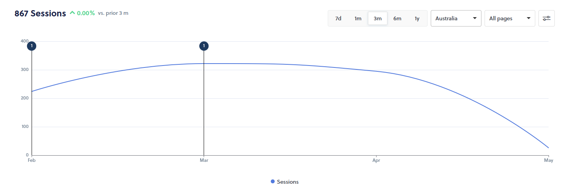
Trails
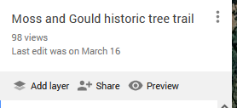
General Business
Walk with Matt.
Next Meeting

